# Problem 2 - Generating Numbers

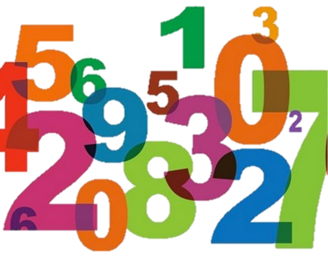

On the **first line,** you will receive a sequence of **integers** separated by a **single space**. On the **next** input **lines**, until you receive the command **"END"**, you will receive a **series of commands** in one of the following formats:

* **"add to start {int1} {int2} … {intn}"** - **add** the integers at the **beginning** of the sequence.
* **"remove greater than {value}"** - **remove every element with value greater** than **{value}** if there are such elements.
* **"replace {value} {replacement}"**:
  + Find **the first occurrence of the element** equal to the given **value** and **replace** it with the given **replacement**.
  + If there **is not** an integer equal to the given **value**,skip the command.
* **"remove at index {index}"**:
  + **Remove** the integer at the given **index**.
  + If the index is **invalid** (**it is valid** when it is **between** **0** and **the index of the last element** **inclusive**), skip the command.
* **"find even"**:
  + **Print** the **even** integers, **separated by a single space**.
* **"find odd"**:
  + **Print** the **odd** integers, **separated by a single space**.

**Note: commands will always be valid.**

After you are done, **print the resulting elements joined by ", "**.

For more clarification, see the examples below.

## Input

* The first input line will hold **a series of integers**, separated by **one whitespace.**
* The following lines will hold **commands** in the described formats (exactly).
* The input ends with the keyword **"END".**
* The input data will always be valid and in the format described. There is no need to check it explicitly.

## Output

* After receiving the "**END**" command, **print the resulting elements joined by ", "**:

**"{element1}, {element2}, {element3}, … {elementN}"**

## Constraints

* The **integers** in the collection will be in the range **[1…1000]**.
* The **number of commands** will be in the range **[1…20]**.
* All commands will be in the described format.

## Examples

|  |  |
| --- | --- |
| **Input** | **Output** |
| 1 2 3 10 10 6 4 10  add to start 1 2 3  remove greater than 5  find even  END | 2 2 4  1, 2, 3, 1, 2, 3, 4 |
| 1 2 3 10 10 6 4 10  replace 10 1  remove at index 0  add to start 4 2  END | 4, 2, 2, 3, 1, 10, 6, 4, 10 |
| 1 2 3 10 10 6 4 10  find odd  replace 4 1  remove greater than 5  END | 1 3  1, 2, 3, 1 |

## JS Examples

|  |  |
| --- | --- |
| **Input** | **Output** |
| (["1 2 3 10 10 6 4 10",  "add to start 1 2 3",  "remove greater than 5",  "find even",  "END"]) | 2 2 4  1, 2, 3, 1, 2, 3, 4 |
| (["1 2 3 10 10 6 4 10",  "replace 10 1",  "remove at index 0",  "add to start 4 2",  "END"]) | 4, 2, 2, 3, 1, 10, 6, 4, 10 |
| (["1 2 3 10 10 6 4 10",  "find odd",  "replace 4 1",  "remove greater than 5",  "END"]) | 1 3  1, 2, 3, 1 |